
FINAL REPORT:
Benefits of Using Data Mining
in Consumer Credit

Net Impact on Profits and Practical Implications of Different Techniques
and Logit Regression Analysis in Particular

MIS 63624.002
Group 12:
Chakradhar Reddy Kothakapa
Prudhvinath Dittakavi
Shang Jiang
Sidney Thomas Block
Executive Summary
Main findings:
- Using an appropriate predictive model allows a substantial increase in profits over the a priori prediction: +$3,399,604.
- Higher profits attained mainly through better prediction and better selection of clients (i.e. stricter). This corresponds to reducing the scope of the business.
- If current selection process / scope of business is kept, interest rates must be raised dramatically to obtain a profit. The necessary raise in interest rates would mostly likely put the bank out of the consumer credit business.
- Available information on credit card customers shows that there are no straightforward association rules for who to sell a savings or checking account to.
Further practical implications and recommendations:
- The amount of information collected in the loan application process should be reduced. Certain information currently collected does not contain any explanatory power regarding a client’s probability of default. This will speed up the application process.
- Base decision on who to give a credit only on client information that has explanatory power regarding a client’s probability of default – even if some seemingly important variables are not considered.
- For clients who just meet the cutoff predicted probability of default to receive a credit, structure credit contract features in a way that helps them to pay back their loan.
- Gained insights can also be used to sell new credits, to target marketing more effectively and to run sensitivity analysis to determine the interest rate that optimizes profits.
- It is important to hire good business intelligence personnel and to educate managers in statistics (what are types of errors and their costs? Should decision weights be used? Should we include opportunity costs in our model selection process?).
Methods used for findings/recommendations:
- Forward logit model with decision weights based on a repeated holdout data partitioning mechanism.
- Association rule mining.
- Further models were run. They yielded no useful or less precise insights (clustering, stepwise logit, logit models based on PCA, decision trees).
Table of Contents
1) Project Motivation and Background 4
2) Data Description 6
3) Unsupervised Learning 7
3.1) Clustering 7
3.2) Association rule mining 7
4) Supervised Learning / Our BI Model 9
4.1) Introduction 9
4.2) Chronological explanation of our model 9
5) EM Diagrams Used 15
6) Findings 16
6.1) Interpretation of the logit output 16
6.2) Analysis of logit model performance 22
6.3) Net impact on profits 25
7) Managerial Implications and Conclusions 29
7.1) Practical benefit of the findings of the logit model / 6.1)? 29
7.2) Practical benefit of the findings regarding model performance / 6.2)? 30
7.3) Practical benefit of the findings regarding net impact on profit / 6.3)? 30
7.5) Conclusions with respect to section 1) 31
8) References 32
Appendix 33

1) Project Motivation and Background
- Our project answers the question of which information can/should be used to predict a consumer bank client’s probability of default. This is of high importance for consumer banks because of three reasons:
  - Information that is found to significantly influence a client’s probability of default can be used to discriminate between who receives a loan and who not. Those clients that are assigned a “too high” probability of default will not receive a credit (“too high” will be specified by the optimal cutoff, see section 4.2).
  - Features of credit contracts that are found to significantly influence a client’s probability of default can be used to design a credit contract in a way that is optimal for a client (i.e lowest risk). For example, if credit amount is found to positively affect probability of default, a riskier client that just suffices the cutoff level should receive a credit with a lower amount. This will help the client to pay back her credit in a commendable manner.
  - Both aspects mentioned above will ultimately yield higher profits for a consumer bank. First and foremost, this will be due to a stricter selection of who to give a credit. We calculated this effect in section 6.3). In addition, other channels that positively impact profit are also conceivable: e.g. sped up processes due to less information that is needed to be gathered. However, the impact on profits of these channels is not determinable with the past data that we have.
- The method we used for answering this question is a forward logit regression based on a repeated holdout partitioning mechanism.
- Above that, we also split the data set we had into different clusters. The underlying idea of this was that bank employees might be able to process loan application much quicker if they can determine the cluster of a potential client quickly. For example, a client that is quickly classified as “Cluster X-Client” would be assigned a much lower risk than a “Cluster Y-Client” and be given a credit with providing less information. Yet, this is only possible if the resulting clusters are easily distinguishable, intuitive and vary in terms of probability of default. The benefit of this clustering procedure would be time savings as this is clearly only a shortcut to the more precise logit regression model.
- In addition to the main question mentioned above, we also tried to briefly answer a secondary question: Is there any potential to sell new services to current loan clients (i.e. sell checking accounts or saving accounts)? Our idea was that the following: If we find association rules between certain variables and a dummy variable for having a checking/savings account (=1 if yes, =0 if no), these rules can be used by consumer banks to sell checking/savings accounts. Specifically, the bank could sell the accounts to its current clients who do not have a checking/savings account right now but are likely to purchase one based on the detected association rules. The value of answering this secondary question is straightforward: higher sales (and most likely profits).

2) Data Description
- Our data set contains information about consumer bank clients who received a loan for multiple purposes (business, cars, electronics etc.) The target variable is whether a client defaulted on a loan or not. Explanatory variables include personal and demographic data (e.g. gender, age, housing, job), financial information (e.g. financial history, installment in % of income) and loan details (e.g. duration, amount).
- See appendix for a complete list of variables and explanations of these variables.
- Summary of data:
How many observations in the dataset? | 5000
How many binary variables? | 1
How many nominal variables? | 13 (all categorical)
How many interval variables? | 8 (one of which is ID)
What is the level of the target variable (nominal, binary or interval)? | Binary
If binary of nominal: What percentage of the variables belong to each class? | 29.9% of cases are default (=1), the other 70.1% of cases are no default (=0)
A priori prediction | Assign all clients the dummy variable default=0 and give all clients a credit

  - No imputation or discarding necessary because no values are missing or noisy.
  - The number of different values for class variables ranges from 2 to 10.

3) Unsupervised Learning

3.1) Clustering
- In section 1), we said that intuitive clusters of clients who differ in probability of default might be useful for bank employees because they allow much faster processing of loan applications. For example, gathering specific detailed information would not be necessary if it is obvious that a person belongs to a certain cluster that has a low probability of default.
- These are the clusters we received when running the clustering node:
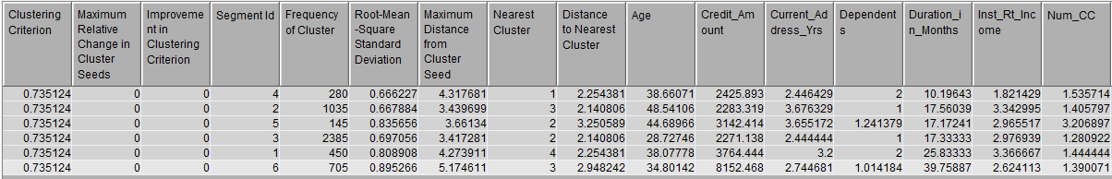
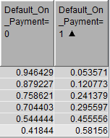
- The clusters were formed only with the few interval variables in our data set. One can see that the clusters do not differ much most of the time (e.g. age and currend_address_yrs for cluster ID4 and ID6). Hence, they are not easily distinguishable. Also, the clusters are not intuitive in that no cluster is characterized by a specific set of values (except for maybe ID6 where customers have a high credit amount and a high duration). This makes classifying a person as a “cluster X”-client very hard. This is particularly problematic because some clusters that are similar in some variables have a very different probability of default (e.g. ID 4 vs. ID6).
- Because of these issues and the minor benefit that clustering might have for the focal bank (rough shortcut of a logit model), we stopped our analysis at this point.

3.2) Association rule mining
- We hypothesized that there might be association rules between explanatory variables and the variables “status checking account” and “status savings account” that can be useful for selling checking/savings accounts. These rules could be used by the focal bank to target sales activities for checking and savings accounts more effectively.
- For our association rule mining trial, we first transformed our data set to have a transactional data set structure. In addition, we renamed certain variables so that the resulting rules would be easier to understand. Lastly, we recoded each the checking and savings account variables to be a dummy: =1 if a client has a checking/savings account and =0 if not. In the original data set, these variables are categorical variables. For simplicity, we did all these transformations in Excel. We submitted the corresponding Excel file in eLearning.
- Our trial was not successful: there are no association rules where the savings/checking account dummy variable is on the right-hand side of an association rule. We used the default settings of the association rule node. Because these results even include rules that have a very low support and confidence, this shows that there is really no strong association rules between the explanatory variables and having a savings/checking account.
- We reported our results in the appendix.

4) Supervised Learning / Our BI Model

4.1) Introduction
- In this section, we describe only the EM diagram we used for prediction to show how we arrived at our final predictive BI model and to show what parameters our final predictive BI model has. A screenshot of this diagram can be found in section 5) “EM Diagrams Used”. We will refer to the final predictive model as “final model” or “main model”. For the discussion in the result section, we changed a few parameters of different nodes in the EM diagram. In each case, we will explain what we changed from our main diagram. However, for clarity, we only outline the structure and settings of our main diagram in section 4.2).
- Section 4.2) is structured as follows: We explain the nodes we used in a chronological order. Please refer to the screenshot of our model to follow the sequence of nodes. For each node, we will highlight what we changed from the default setting and explain why we applied these settings. Note that, for a better understanding, we will break the chronological order and will explain a few nodes just at the end of 4.2).

4.2) Chronological explanation of our model
Import node:
- To import our excel file.
Replace node:
- To rename variables so that they are understandable.
- In the original data set, categorical variables are coded in a way that they are not understandable. Instead, one needs to refer to a variable list that explains each variable. Just for reference, we attached this list in the appendix (section Variable Description).
Stat explore node:
- To get an idea of variables’ distribution. In particular, scales, means and skewness.
Transform node:
- To use log transformation for all interval variables (not possible / sensible for categorical or dummy variables).
- Initially, we applied the transformation only to variables that had a skewness of equal or more than the absolute value of 1. The variables age, number of dependents and installments in % of disposable income remained. However, age had a skewness very close to 1, so we decided to apply the transformation as well. Ultimately, we also applied the transformation to the last two interval variables to ensure consistency in interpretation (linear-log model for each interval variable).
- Transforming variables with a skewness below 1 should not pose a problem as there are no costs of transforming variables (we keep the original variation and only change the magnitude of variation).
Data Partition node:
- As discussed in class, we applied the common split of 50% train, 25% test and 25% validation data. We kept the initial seed value of 12345.
Decision node:
- To apply different costs and revenues to specific types of errors. In our data set, this is highly important as the costs of a false negative (predict no default and give credit even though customer defaulted; type 2) by far outweigh the costs of a false positive (predict default and do not give credit even though customer did not default; type 1).
- Specifically, we assigned the following costs and revenues:
  - Cost of Type 2 error / predict no default but actual default:
Average size of credit. This is $3220 (taken from stat explore node).
  - Cost of Type 1 error / predict default but no actual default: 0.
No costs and revenues as no credit was given.
  - Cost of a true positive / predict default and actual default: 0
  - Revenue of true negative / predict no default and no actual default
    - We determined the interest rate as follows:
      - Assumed mean interest rate: 7% p.a.
      - This is a rounded average of:
        - Mean rate for car loans (48 months) in 2016: 4.30% p.a.
        - Mean rate for personal loans in 2016: 9.69% p.a.
        - These data are taken from the FED (see references).
      - We took the average contract duration from the stat explore node.
- Note that these costs and revenues reflect only revenues and costs that actually impact the profit and loss of the focal bank. These costs and revenues do not include opportunity costs or implicit costs. For our data set, these would be the forgone profits that are due to a Type 1 error (not given a credit despite no actual default). Analogously to the true negative (give a credit, no actual default), we would have assigned a value of -425 to this cost. However, we decided to only include actual revenues and costs because a) we are interested in the net impact on real profit and b) the cumulative expected profits are affected extremely negatively (no profit at all, large losses) by considering implicit costs. Ultimately, these results would not have been sensible anymore (more on this in the results section).
- In addition, we chose the following two options:
  - Decision tab - “Do you want to use these rules?” → Yes. Otherwise, the model selection node would not calculate / display (cumulative) profits and losses.
  - Decision weights tab – “Maximize” → Yes. This way, the model selection node selects the best model based on the largest overall (cumulated) profit. We did this because we are much more interested in a higher upside (i.e. profit) than a lower downside (i.e. losses). If we had chosen No, the node would have selected the model with the lowest loss.
PCA node:
- To reduce data dimensions.
- As outlined in our proposal and progress report, we chose the logit model over other supervised learning methods because we wanted to obtain information on how specific variables affect the probability of default.
- Yet, we still ran a logit model with a transformed data set to see whether we could improve prediction. If this had been the case, we would have used the PCA-based logit model for prediction and would have referred to another logit model without PCA to determine the effects specific variables. However, the models we ran based on PCA were always worse than the models we ran without (based on misclassification rate, profit etc.).
- For further reassurance, we also ran a decision tree and saw that the results are worse than the results for our final chosen logit model. The results were as follows:
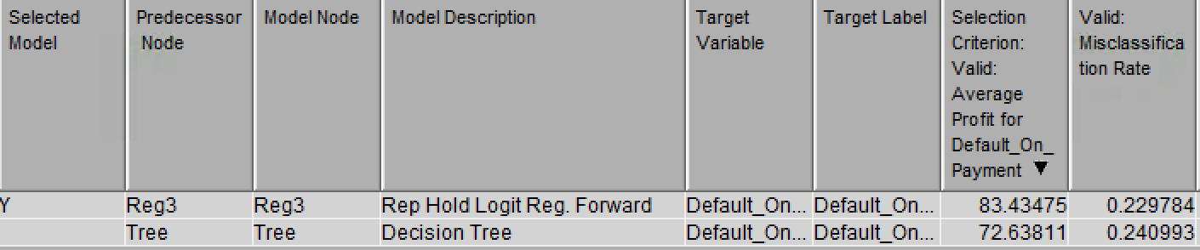
*More on the regression in “forward regression nodes” below and the results section.

Data Partition Rep Hold:
- To apply a repeated holdout mechanism to reduce the dependability of the results on the initial seed number.
  - We used the following seed numbers: 12345, 72, 653, 253, 200, 913, 2516, 4609, 1993, 3308. Of these, 200 appeared to be the best one based on cumulated total expected profits ($91,104; reported at depth 100% if not specified differently) or average profit per observation ($83.43) in the validation data set. All other seeds had worse cumulated total expected profits. Sometimes, the average profit per observation was higher but we chose 200 because we assigned cumulated total expected profits a higher importance.
- To apply different allocations of data (with constant seed of 200).
  - Initial allocation: 50% train, 25% test, 25% validation (see above). This resulted in the $91,104 cumulated total expected profit and $83.43 average profit per observation for the validation data set given above.
  - We stuck to this allocation because the alternative allocations delivered worse results:
    - 60% train, 15% test, 25% validation. This resulted in $82,682 cumulated total expected profit and $89.75 average profit per observation for the validation data set. In addition, it resulted in $66,2 cumulated expected profit.
    - 70% train, 10% test, 20% validation. This resulted in $66,2 dollar cumulated expected profit and $86.99 average profit per observation for the validation data set. These figures are equal or worse than the 60%, 15%, 25% partition which is worse than the 50%, 25%, 25% partition. We could not refer to the cumulative total expected profit for the 70% train partition as the number of observations in the validation data set was smaller, making the cumulative profit incomparable.
Forward logit model nodes:
- To apply a supervised learning method.
- We used a forward logit model because of these reasons:
  - For a discussion on why we chose logit over other supervised methods we learned in class, see PCA node in this section.
  - A regular logit model was not suitable because we knew from the proposal that some of the variables in our data set were insignificant. In this case, the question is which variables to discard and which to keep in the regression equation. Instead of trying by hand, we decided to use either a forward or stepwise regression model to make the estimation process less cumbersome (adding and dropping by hand).
  - Stepwise and forward regressions delivered the exact same results. As discussed in class, one should chose the forward model in this case because the predictive power of the models is the same while the forward model is more efficient then the stepwise model.
  - The results were as follows:
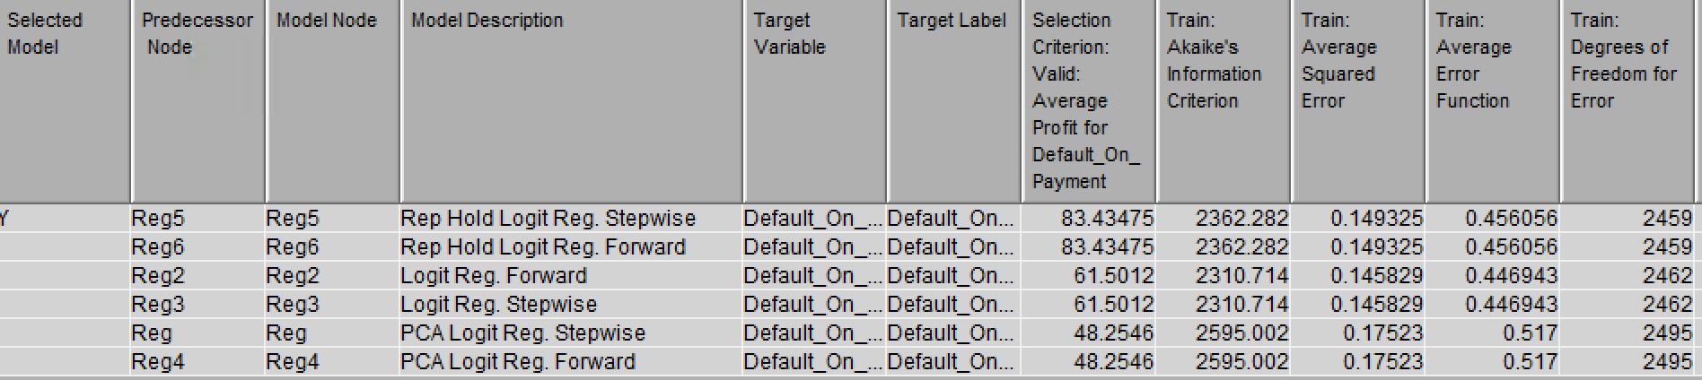
Model selection node:
- To select the model that classifies data in a way that maximizes profits.
- We did not change the default settings. This translates to SAS EM selecting models by considering the costs and revenues we specified for the different types of errors and correct classifications. If we had chosen misclassification rate as selection criterion, SAS EM would have not taken these costs and revenues into account. In addition, SAS EM would not have reported (cumulated) profits data / displayed (cumulated) profits charts.
Cutoff node (and SAS code node):
- To receive data on the number of true positives, false positive, true negatives and false negatives at different cutoff levels. In addition, receive information on which cutoff level was chosen by the combination of decision, regression and model selection node.
- We selected the option “Maximize cumulated profits” to determine the optimal cutoff. The chosen optimal cutoff at the prior probability of 29.9% (equals the percentage of defaults in the data set) was 42%. This value is in line with the fact that a type 2 error is costlier than a type 1 error. This is because at equal costs, the cutoff is 50%. At a cutoff of 42%, we assign observations more quickly to be a default observation to avoid the loss of a defaulting customer.
- Initially, we also used the cutoff node in combination with the SAS code node to score the observations in the validation data based user specified cutoffs (following the idea just above; see “initial model” screenshot in appendix). However, the cutoff node loses its ability to influence scoring once decision rules are activated and decision weights are assigned in the decision node. This is in line with intuition as the combination of decision node, logit model and model selection automatically choses the optimal cutoff based on the information the user specified in the decision node.
Score node:
- To get information on how the observations were classified and how the decision node changed the classification.
- This information is mainly useful to check whether the BI model works in the way it should be (i.e. how does scoring change if we change the costs and revenues of specific errors/classifications).
Logit w/o decision weights, cutoff and score node:
- To calculate the cumulated total expected profit that a forward logit model without decision weights would yield, we ran a further combination of a forward logit, cutoff and score node that had the same prior path than the final regression (repeated holdout forward logit). The only difference was that the decision node was missing.
- We did this to establish the value that applying decision weights has.

5) EM Diagrams Used
Final diagram for the logit models:
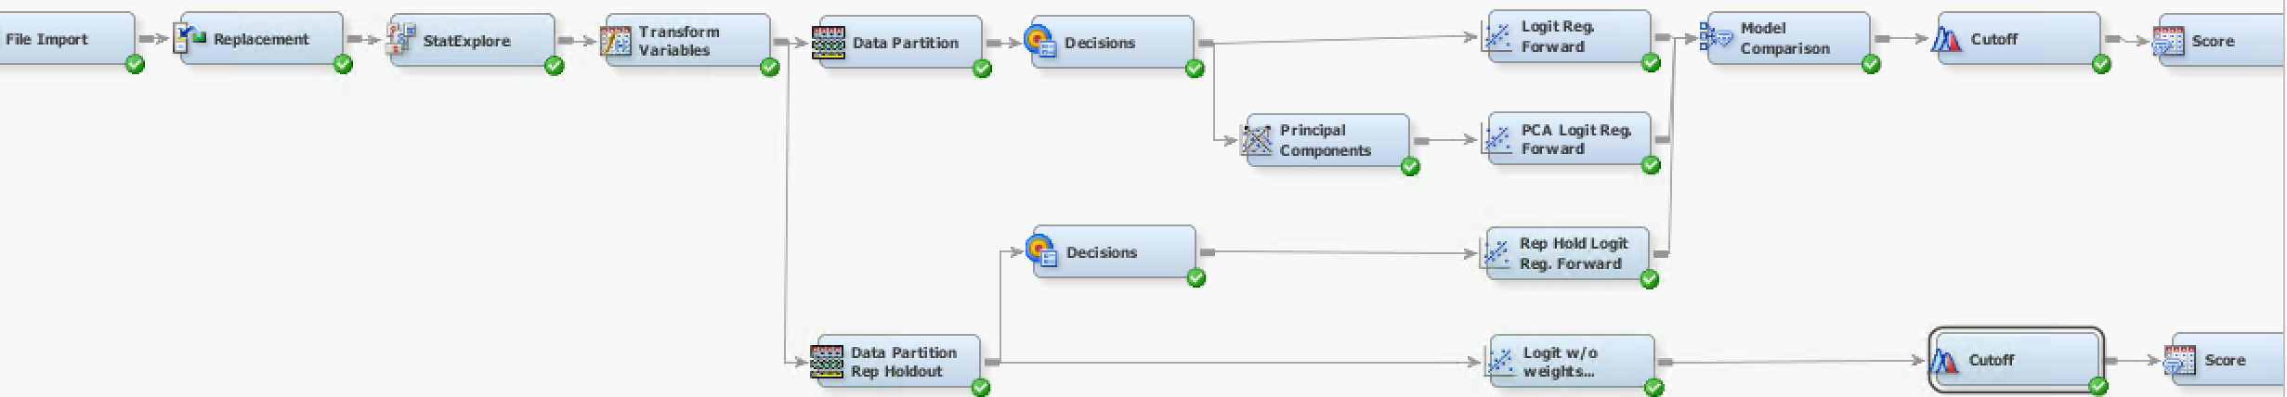

Final diagram for clustering:


Final diagram for association rule mining:


6) Findings

6.1) Interpretation of the logit output
- Of the three forward regressions we ran in the final diagram, the model selection node chose the forward regression that used a data partitioning based on a repeated holdout procedure and did not use PCA:
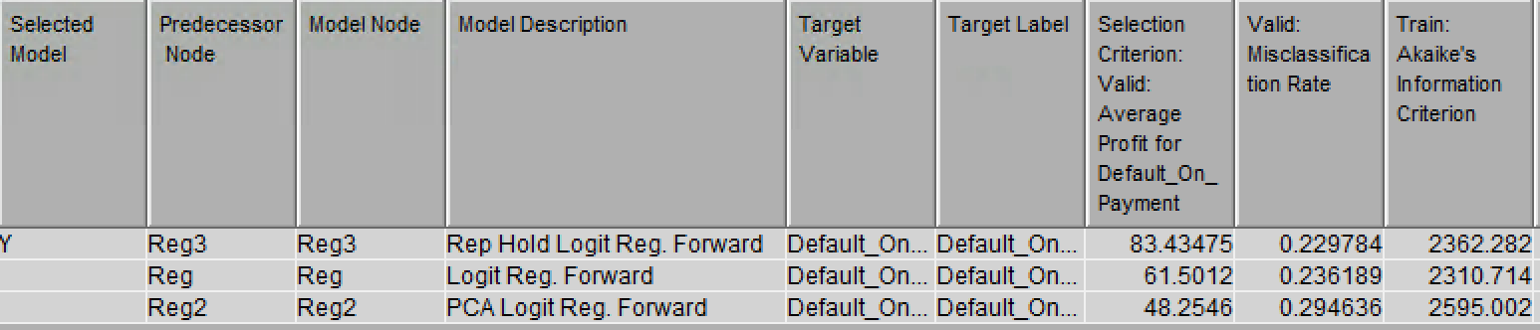
  - As one can easily see, the model has the highest average profit and, thus, yields the highest cumulative profit. In addition, it also has the lowest misclassification rate.
  - Because profits based on our decision weights are our main decision criterion, we decided to stick which the selected model.
  - You will find more detailed information on other results (e.g. FOC, Lift etc.) in section 2.2)
- The final forward regression includes 14 out of 20 available explanatory variables. Three of these are interval and 11 are categorical variables (see appendix for complete regression results).
- The following 2x2 matrix compares the significance of all variables to our prior expectations. Note that, for brevity, we classify categorical variables as significant if at least 50% of the corresponding dummy variables are significant (at 5%).
 | Expected significant | Expected insignificant
Significant | - Duration in months  - Installments % of disposable income  - Number of credits  - Credit history  - Other debtors and guarantors  - Other installment plans  - Status of savings account  - Status of checking account | - Foreign worker  - Years at current employer
Insignificant | - Type of housing  - Type of property owned  - Purpose of credit taken  - Age  - Number of dependents | - Marital status and gender  - Credit amount  - Present residence since (years)  - Type of job  - Telephone number
Variables in black are included in the final forward regression. Variables in grey are not.

- Significant and expected significant
  - Duration in months: More outside factors can impact the client’s ability to pay back the credit (e.g. sudden unemployment or illness).
  - Installments in % of disposable income: It determines the amount of money that is available to pay back a credit.
  - Number of credits: A higher number of credits means that a person must pay back several credits at a time. This clearly reduces the money available to pay back a specific credit.
  - Credit history: Past data on a client’s financial prudency should have some explanatory value for the client’s current or future financial prudency.
  - Other debtors and guarantors:
Another debtor / guarantor can be held responsible for paying back the credit if the main client has insufficient funds.
  - Other installment plans: A higher number of other installment plans entails that less money is available to pay back the loan at the focal bank.
  - Status of savings account: A positive (negative) balance indicates that more (less) money is available to pay back the loan at the focal bank.
  - Status of checking account: A positive (negative) balance indicates that more (less) money is available to pay back the loan at the focal bank.
- Significant and expected insignificant. These were surprising because…
  - Foreign worker: We would think that, ceteris paribus (e.g. type of job, savings etc.), being a foreign worker should not influence probability of default because ethnicity should be orthogonal to financial behavior.
  - Years at current employer: There are several contrary effects at work which should overall lead to an ambiguous relationship. This should result in an insignificant effect. For example, it might be that a person just switched employers because she got a raise at a new company. In contrast, it might also be that a person stayed at a company because she got a raise there. In addition, we think that the significance of this variable might stem from the fact that it is strongly correlated with years of work experience. Thus, it only might capture the positive effect that years of work experience has on wages.

- Insignificant and expected significant
  - Type of housing: These were a) own house b) rent and c) for free. We expected a) and b) to have a negative effect on default probability because a) and b) indicate that someone has liquidity (mortgages or rent is paid regularly). In contrast, c) indicates that someone does not even have enough money to pay her housing.
  - Type of property: These indicated whether a person had a car, real estate, live insurance etc. We expected a negative impact on default probability because only people who have sufficient funds can invest in property. Also, certain property can be sold to service debt.
  - Age: We expected older people to have a lower probability of default. This is because they tend to have higher income and tend to be financially more responsible. For example, younger people are more likely to take out a consumer loan to buy a fancy technology product.
  - Purpose of credit taken: If the purpose of the credit is a sensible long-term investment (e.g. education), the likelihood that the person acts financially responsible should be higher compared to when the purpose of the credit is directed at short-term consumption (e.g. electronics).
  - Number of dependents: We expected a negative correlation with probability of default. This is because a higher number of dependents means higher money to be spent for other purposes than servicing debt.
- Insignificant and expected insignificant:
  - Holding everything else equal, these variables themselves should not carry explanatory power with respect to the probability of default. We could not come up with a reason why they should be significant.
  - Only exception: Credit amount. For this variable, we expected insignificant results because of two contrary effects: a) A higher credit amount is harder to pay off simply because it is a higher amount (=higher probability of default) b) A high credit amount is only granted to those people with a high income and property (=lower probability of default).
- Interpretation of the regression estimates:
  - We will restrict ourselves to interpret the coefficients of one interval variable and one dummy variable.
  - This is because interpretation can be done analogously for every variable. In addition, the magnitude of the logit coefficients does not carry too much information since the coefficients always refer to a fraction/multiple of prior odds ratios. These obviously vary dramatically for different observation. Hence, the actual change in the probability of default varies dramatically for different observations.
    - Example interpretation 1 – Interval variable: If installment payments make up one percentage point more of a client’s disposable income, a client’s probability of default increases, on average, by 85.4 percentage points, ceteris paribus.
New odds ratio: 1.854 of prior odds ratio
This corresponds to an increase of: 1.854-1 = 1.854 or 85.4%
    - Example interpretation 2 – Dummy variable: If a client has no installment plans, the client’s probability of default, on average, increases by 34.9 percentage points compared to the baseline group of clients having an installment plan at a store, ceteris paribus.
New odds ratio: 0.651 of prior odds ratio
This corresponds to a decrease of: (1-0.651) = 0.349 or 34.9%
- However, in contrast to the magnitude, the interpretation of coefficients’ signs is much more straightforward. Again, we made use of a 2x2 matrix to see whether results are in line with our expectations. This time, we show significant variables in the final forward regression which have (un)expected signs:

Signs | Expected positive | Expected negative
Positive | - Duration in months  - Installments % of disposable income  - Number of credits  - Credit History: all credits at this bank paid back duly vs. base=all credits paid back duly  - Martial & Gender: male – divorced / separated vs. base=male single  - Credit History: critical account vs. base=all credits paid back duly | - Other Debtors/Guarantors: co-applicant vs. base=none  - Purpose of credit: new car vs. base group=retraining  - Purpose of credit: repairs vs. base group=retraining  - Savings account: less than 1k vs. base=no savings account  - Years at current employer: less than 1 year vs. base=unemployed
Negative | - Foreign worker yes vs. base=no | - Other Debtors/Guarantors: guarantor vs. base=none  - Other installment plans: none vs. base=store  - Purpose of credit: used car vs. base group=retraining  - Savings account: more than 10k vs. base=no savings account  - Years at current employer: 4-7 years vs. base=unemployed  - Property: real estate vs. base=no property

- This time, we elaborate only on cases where signs are contrary to our expectations. This is because most of them should be intuitive and are already implied by our discussion regarding significance:
  - Expected a negative sign but actual sign is positive:
    - Other Debtors/Guarantors - co-applicant vs. base=none: A co-applicant can be held responsible when the main client defaults.
    - Purpose of credit – new car & repairs vs. retraining: Retraining indicates that a client is in severe financial problems. Thus, any other purpose than retraining should lead to a lower probability of default.
    - Savings account - less than 1k vs. base=no savings account: Every dollar in a savings account should lower the probability of default compared to having no savings at all.
    - Years at current employer - less than 1 year vs. base=unemployed: Every amount of time at a current employer should be better than having no job at all.
  - Expected a positive sign but actual sign is negative:
    - Foreign workers: As outlined above, we would expect this variable to have no effect at all.
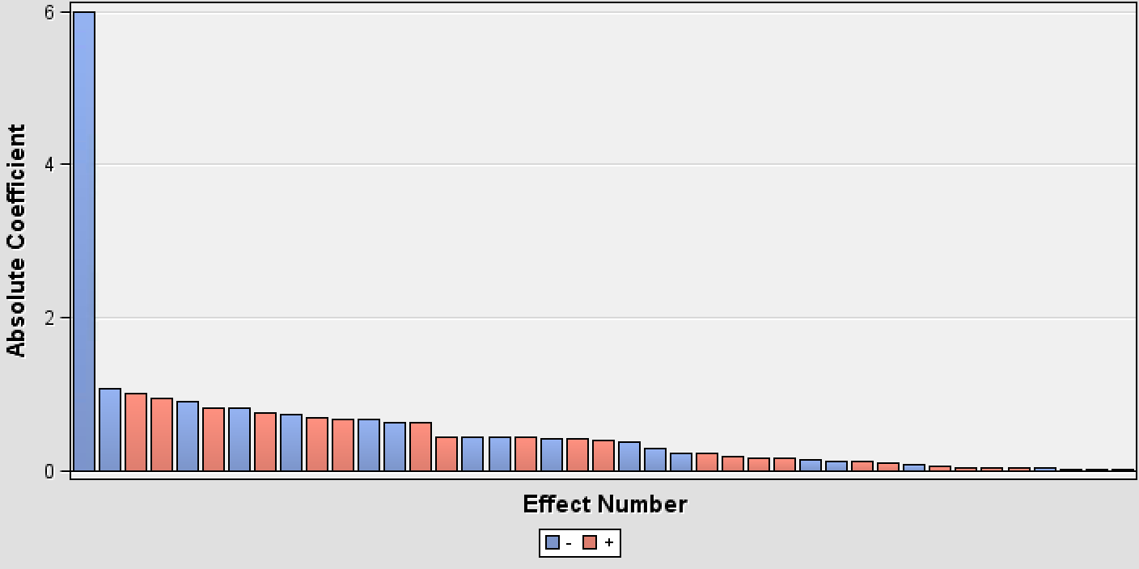
- Lastly, we want to elaborate on the effects plot. The effects plot shows how much a specific explanatory variable contributes to explain the dependent variable. This is very useful for a logit model because the marginal change that is due to a change in an explanatory variable is different for every observation (see explanation above). In addition, significance levels do not tell anything about how much a significant variable contributes to explaining the dependent variable compared to other significant variables.
  - From this graph, one can see that most variables contribute almost equally to explaining the probability of default. The only variable that has a very high effect coefficient is the first one. However, this is the intercept and the intercept does not carry any informational information because it specifies the irrelevant case of an observation in the base group. This group is irrelevant because there are no observations in this group (e.g. credit duration=0). Hence, we can conclude that from the significant variables, no variable is dominating any other variables in terms of explanatory content for the dependent variable. Thus, it does not seem necessary for the bank to pay special attention to a subset of the significant variables when giving out a credit.

6.2) Analysis of logit model performance
- Lift chart
  - The lift of a good model should fall smoothly.
  - Our model (Rep Hold Logit Reg Forward): The lift falls. However, it does not fall smoothly because the lift sometimes rises to levels that a higher than the lift of the previous decile. Hence, the model could perform better.
  - Nevertheless, the model does a good job of classifying observations into default or no-default clients because the lift levels of low depths are high and the lift levels of high levels are very low. This indicates substantial differences to the prediction one would make without any predictive model.
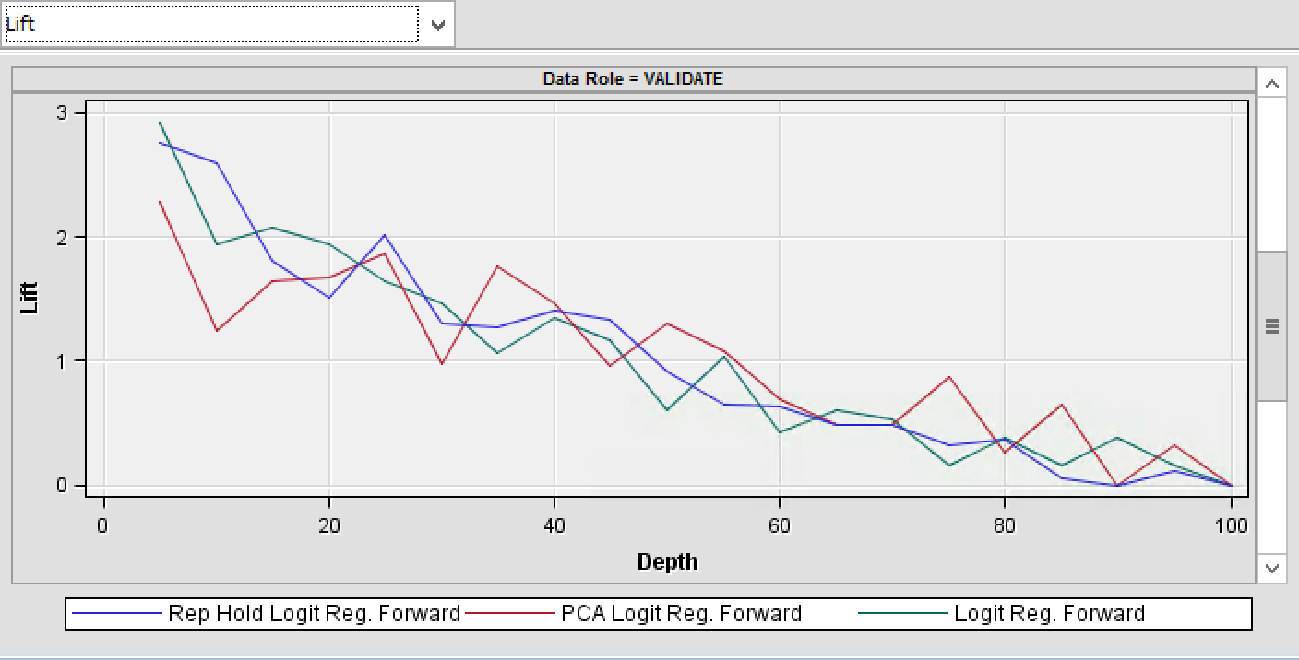
- ROC chart
  - The chart displays the probability of classifying false positive on the x-axis and the probability of true positives on the y-axis. A good model has a curve that is close to the upper right corner. This means that all observation that are classified as positive are classified correctly.
  - For our model, this chart is not of high importance as there are no costs and no revenues of classifying a client as a default client / positively. Hence, we refrain from elaborating too much on this measure.
  - Our model (Data role = Validate and Rep Hold Logit Reg. Forward): The model is a substantial improvement to the diagonal which corresponds to random guessing. However, there is room for improvement with respect to classifying default=1 correctly.
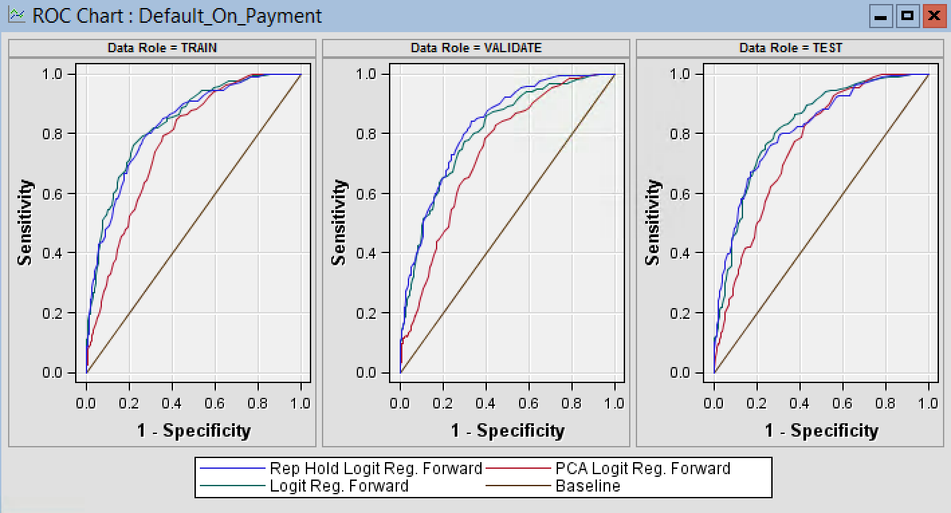
- Profit charts
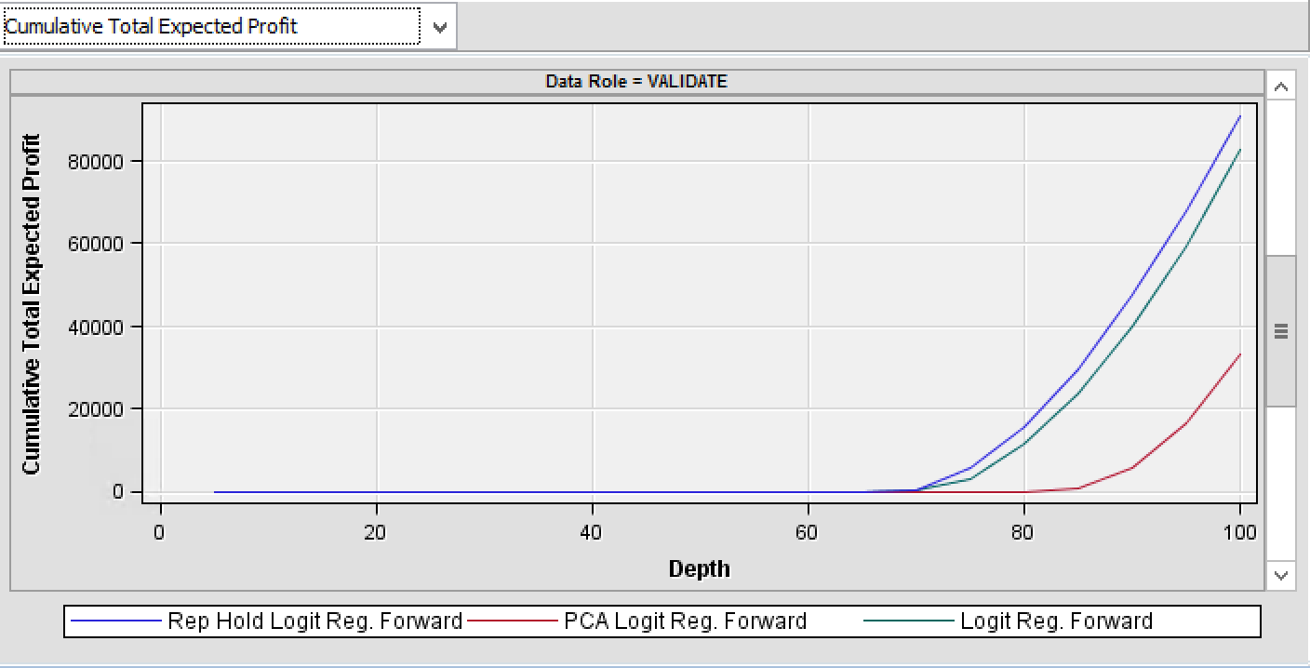
  - Total expected cumulated profit at depth 100% is $91,104. Profits start to rise at approximately depth 70%. Before that, no client admitted because the predicted probability of default of a client is too high and, thus, the client’s predicted contribution to profits is zero.

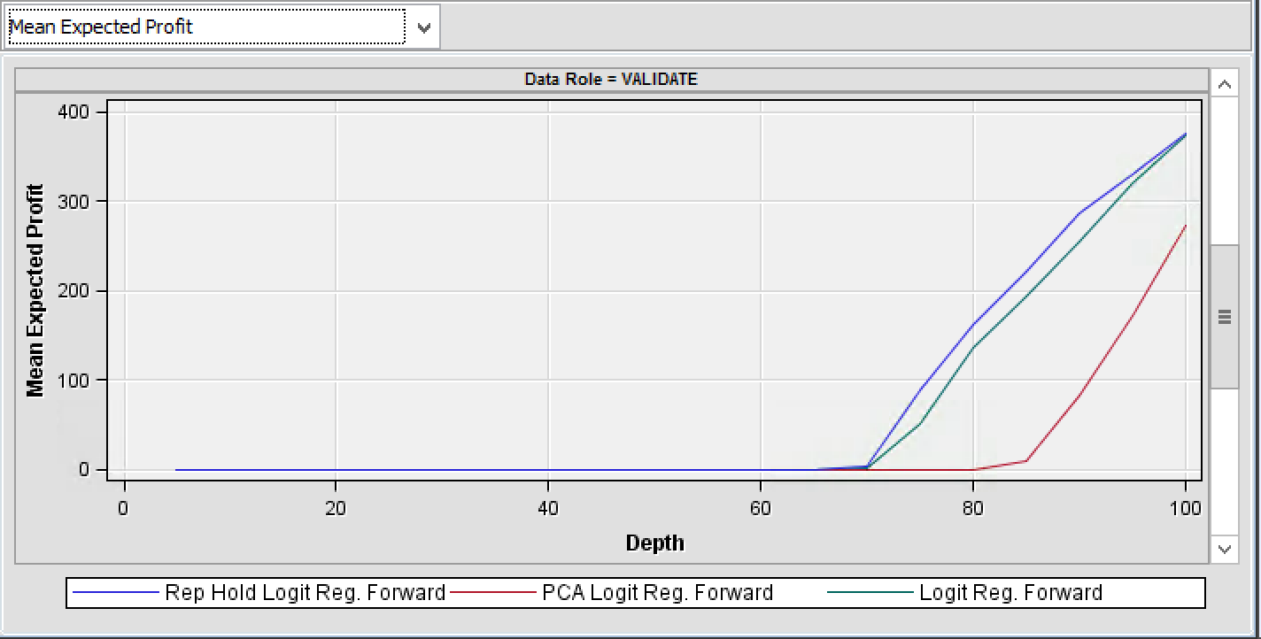
  - Mean expected profit rises from $0.52 at depth 70% to $374 at depth 100%.

  - This pattern is line with the scoring node:
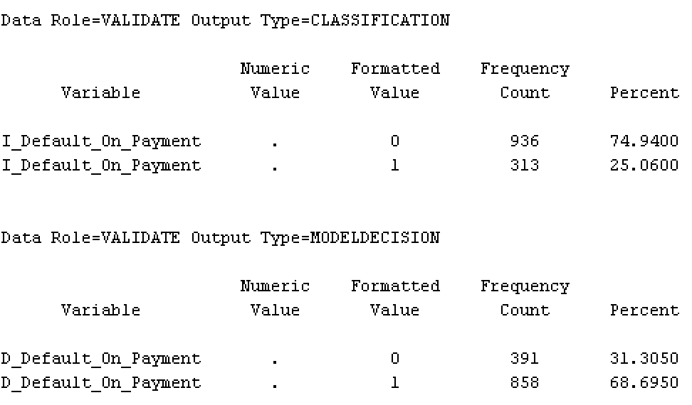
    - We see that after correcting for the decision weights, roughly 70% of the sample are classified as default probability = 100% and, thus, not given a credit. Put differently, only the observations with the 30% lowest probability of default are given a credit. Only with these customers, the focal bank makes money.
    - The change from the classification to the model decision table is consistent the assigned decision weights: There are no costs for a false positive but large costs for a false negative. Thus, to maximize profits, the cutoff for begin assign default on payment=0 should be reduced. As a result, a lower percentage of observations should be classified as no default.
      - This reasoning is confirmed by the cutoff node: The applied cutoff level of 42% is lower than the default level of 50% if no weights are assigned.
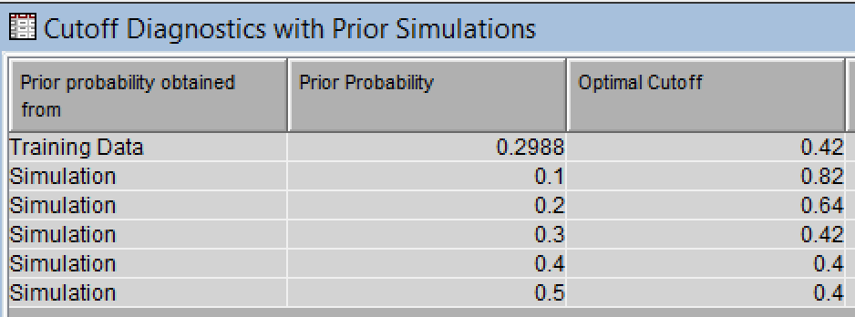

6.3) Net impact on profits

Model  Description | Decision Weights | Misclassification Rate  (model selection node) | Profit Classification  (score node) | Cumulative  Total Expected Profit at Depth 100%  (model selection node)
Final logit | See above: weights for false negative and true negative  No opportunity cost for false positive | 22.98% | Before weights:  - Default=0: 74.9%  - Default=1: 25.1%  After weights:  - Default=0: 31.3%  - Default=1: 68.7% | $91,104
A priori prediction: classify all obs. as default=0 | None  Considering only false negatives and true negatives  (Considering false positive would not make a difference because all observations are assigned default=0) | 29.88%  = % of default in sample | Default=0: 100%  all receive credit | -$3,308,500*
Final logit (2) | Weights for false negative, true negative  and opportunity costs for false positive | 22.82% | Before weights:  - Default=0: 74.9%  - Default=1: 25.1%  After weights:  - Default=0: 46.2%  - Default=1: 53.8% | -$84,820
Logit without decision weights | None  Considering only false negatives and true negatives | 23.62% | Default=0: 74.5%  Default=1: 25.5%  True negative:  - 733 out of 1250 at optimal cutoff= 58.64%  False negative:  - 149 out of 1250 at optimal cutoff= 11.92% | -$675,760**
* Calculated as follows:
- Expected profit per customer: (expected revenue per customer – expected cost per customer) =
[(1-misclassification rate) * revenue of giving credit]- (misclassification rate * cost of default) =
(70.12%*$420) - (29.88%*$3200) = $294.5-$956.2 = -$661.7
- Cumulated total expected profit at depth 100%: Expected profit per customer*number of observations in data set = -$661.7*5000=-$3,308,500
** Calculated as follows:
- Overall profit = Overall revenue – overall costs
- Overall revenue: % of true negatives*sample size*revenue for true negatives
- Overall costs: % of false negatives*sample size*cost for false negatives
- Hence: (58.64%*5000*$420) - (11.92%*5000*$3200) = $1,231,440-$1,907,200= -$675,760
- Our main model / final logit:
  - The model has the highest profit and is the only model with positive profits. In addition, the differences between profits of the final logit and losses of all other models are strikingly large.
  - In particular, our main model seems to be a huge improvement compared to the a priori prediction and the model without decision weights ($3,399,604 or $766,774 higher profit a priori prediction or model without decision weights, respectively).
- A priori prediction:
  - The loss of the a priori prediction is extremely high. This underscores the importance of strong predictive models in consumer credit.
  - With the a priori prediction accuracy, the bank would have to raise interest rates dramatically to even reach break-even or the profit attained with our main logit model:
Interest rate necessary to break-even:
- Intuition: Break-even is attained if average profit per observation is 0 at depth 100%. We can modify the revenue of a true negative by changing the interest rate. We cannot the costs of a false positive (mean credit amount).

- This is equal to:

- This yields an interest rate of:

Interest rate necessary to reach profit of main model:
- Calculation analogously. Average profit per observation needs to be $83.44 (see forward logit node explanation).

- Needed revenue per true positive:
- Needed interest rate:
  - These interest rates are extremely high for consumer credit loans. In fact, they are so high that no customer would take a loan at the bank anymore. This is equivalent to the focal bank going out of business. These results highlight that a good predictive model is essential to being able to compete in the consumer credit industry.
- Final logit (2) results / why we did not include opportunity costs:
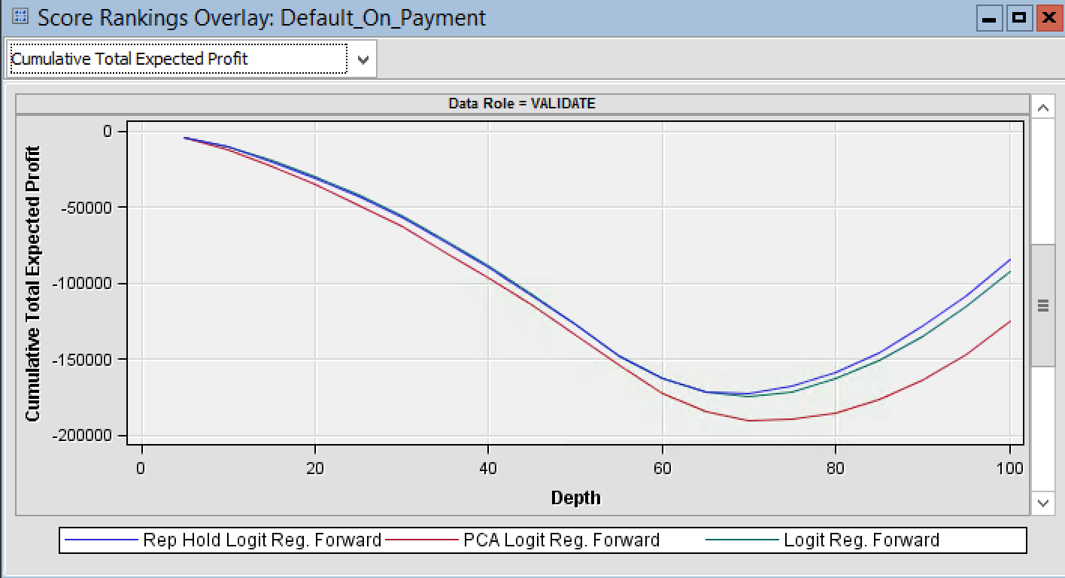
  - As we can see, the cumulated profit of this model is never above 0. This is highly unrealistic as the focal bank could simply admit the 20 to 30% best customers that are almost certainly not going to default (as we have seen in our final model above).
  - Essentially, taking opportunity costs/costs for a false positive into account “distorts” the real profits of the consumer credit business by considering costs that do not occur in reality.
  - Hence, adding opportunity costs to the decision weights leads the bank to make irrational decisions / decisions that do not maximize NPV. Thus, opportunity costs should not be regarded when specifying the final classification model / making the decision to whom to give a credit.
- Logit model without decision weights:
  - Compared to the a priori prediction, this model yields a significant improvement in terms of profit. This shows that using a predictive model is much than using no prediction / the a priori prediction.
  - Compared to our main model, we see that the misclassification rates of both models are very close. However, the resulting profit varies drastically. This highlights the importance of assigning decision weights when choosing a predictive model.

7) Managerial Implications and Conclusions

7.1) Practical benefit of the findings of the logit model / 6.1)?
- First, implement a systematic way of giving out credits if not already in place.
- If there already is a systematic way of giving out credits: Change which variables are used to decide whether a person receives a loan.
  - Make use only of significant variables. Do not use insignificant ones.
  - This should be done even if these variables are expected to be important a priori (e.g. age or number of dependents).
- Change collection of information: Only ask for variables that are significant. By doing this, no long application needs to be filled out anymore. This could speed up the application process and maybe attract a few new customers.
- Do not place more weight on a specific variable than on other variables:
  - From the effect plot we concluded that all variables contribute somewhat equally to the probability of default. Hence, overweighting certain variables when deciding to give a credit might increase the actual risk of having a client default.
  - This should be highlighted especially for variables that, intuitively, seem to be more important than other variables (e.g. installments in % of disposable income vs. status of checking account).
- Offer specific bundles of credit contract features to specific types of customers. I.e. high risk clients should only receive low credit amount, low duration etc.
  - For example, we saw that the duration of a credit increases the probability of default. Hence, if a customer receives a credit but has a relatively high level of default, she could be offered a credit with shorter duration. This might decrease the risk that outside changes reduce the solvency of a client (e.g. unemployment).
- Use information on clients of the focal bank to offer new credits:
  - For those clients who do not have a credit taken out yet, predict which customers would be low risk credit customers (i.e. below the cutoff of not giving a credit). The bank should offer those customers to take out a credit.

- Use information to spend marketing budget more effectively:
  - Use the characteristics that decrease probability of default for a targeted online marketing campaign (as these allow detailed targeting). For example, target foreign workers by e.g. targeting people with Spanish browser language.

7.2) Practical benefit of the findings regarding model performance / 6.2)?
- In the cumulative profit chart, one can see that only the 30% of customer receive credits who have the lowest probability of default. Because the data set we use is based on already given credits, we can deduce that the bank gave out credits too easily in the past.
- Hence, the bank should give out credits more strictly. Specifically, the decision process should be based on a predictive model with decision weights that has a lower cutoff than 50% (our model had a cutoff of 42%).

7.3) Practical benefit of the findings regarding net impact on profit / 6.3)?
- 6.1) and 6.2) talk about what actions the focal bank can take based on the insights gained from our logit model output. These recommendations are qualitative and their final value for the business needs to be tested by applying the recommendations and by collecting insightful data about how the probability of default / profit changes.
- In contrast, this section is concerned with what the net value of using a predictive model with decision weights is. We will express this per 5000 customers / at depth 100%, assuming this is a large retail bank.
- Final logit and a priori prediction comparison:
  - In section 6.3) we saw that with using the accuracy of the a priori prediction, the focal bank would go out of business because the interest rates it needs to charge are way too high for the consumer credit industry. This demonstrates that implementing a good predictive model is vital to a bank’s survival. It also shows that it is essential to hire the right personnel for business intelligence.
  - Section 6.3) also shows that one could implement a sensitivity analysis to find the optimal interest rate: One could iteratively adjust the interest rate that is charged for a credit. Then, one could re-run the logit model for every interest rate to find the interest rate with the highest cumulative total expected profit.
  - Like section 6.2), the profit comparison of the models highlights that being more selective when deciding on who to give a credit increases profits.

- Final logit and logit with opportunity cost comparison:
  - Do not use opportunity costs when assigning decision weights because these might lead to irrational decisions. One should only use them to compare the attractiveness of investment decisions.
- Final logit and logit without decision weights comparison:
  - Because the profit of the final logit is much higher, one should use decision weights when predicting.
  - Again, this implies that one should hire good business intelligence personnel. In addition, it appears to be essential to educate managers on the costs associated with different types of errors.

7.5) Conclusions with respect to section 1)
- We successfully answered our main question by discussing which variables should be used to determine a client’s probability of default. By using this information in combination with decision weights and the cutoff node for prediction, we established which clients the bank should give a credit and which not. In addition, we described how specific credit contract features impact a client’s probability of default and elaborated on how this information can be used to optimize a client’s probability of default. Furthermore, we determined the net profit of using different models compared to the a priori prediction that is inherent in our data set. In particular, we showed that our final logit model yields a much higher profit than the a priori prediction. Lastly, we provided further qualitative insights that might be beneficial for the focal bank (e.g. hire right personnel, target marketing etc.).
- In addition, we also answered our secondary question: There are no helpful association rules in our data set that help consumer banks to sell more savings and checking accounts to current clients.

8) References
Federal Reserve (2017), “Consumer Credit – G.19”, available at: https://www.federalreserve.gov/releases/g19/current/ [accessed: Nov. 15th, 2017]

Appendix
Variable Description

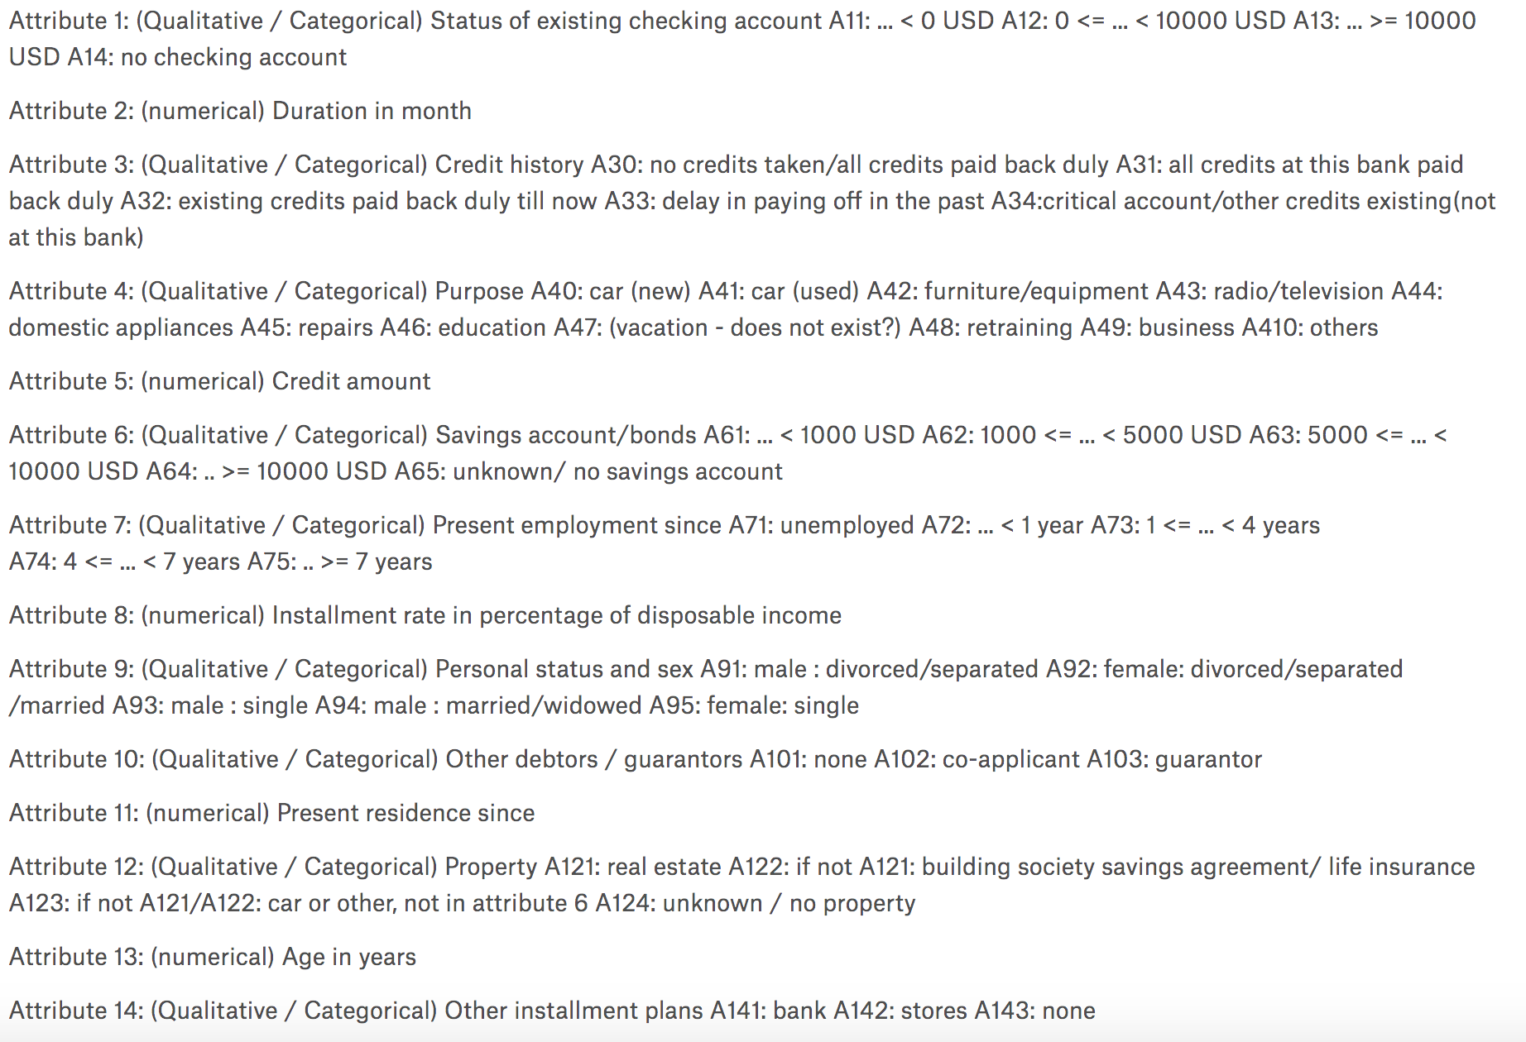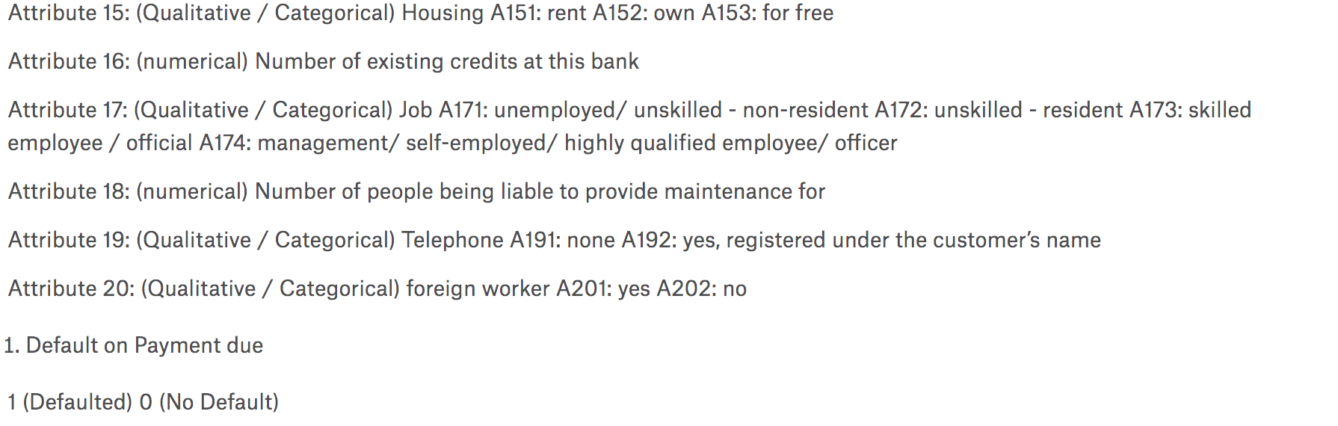

Results
Association Rule Mining:
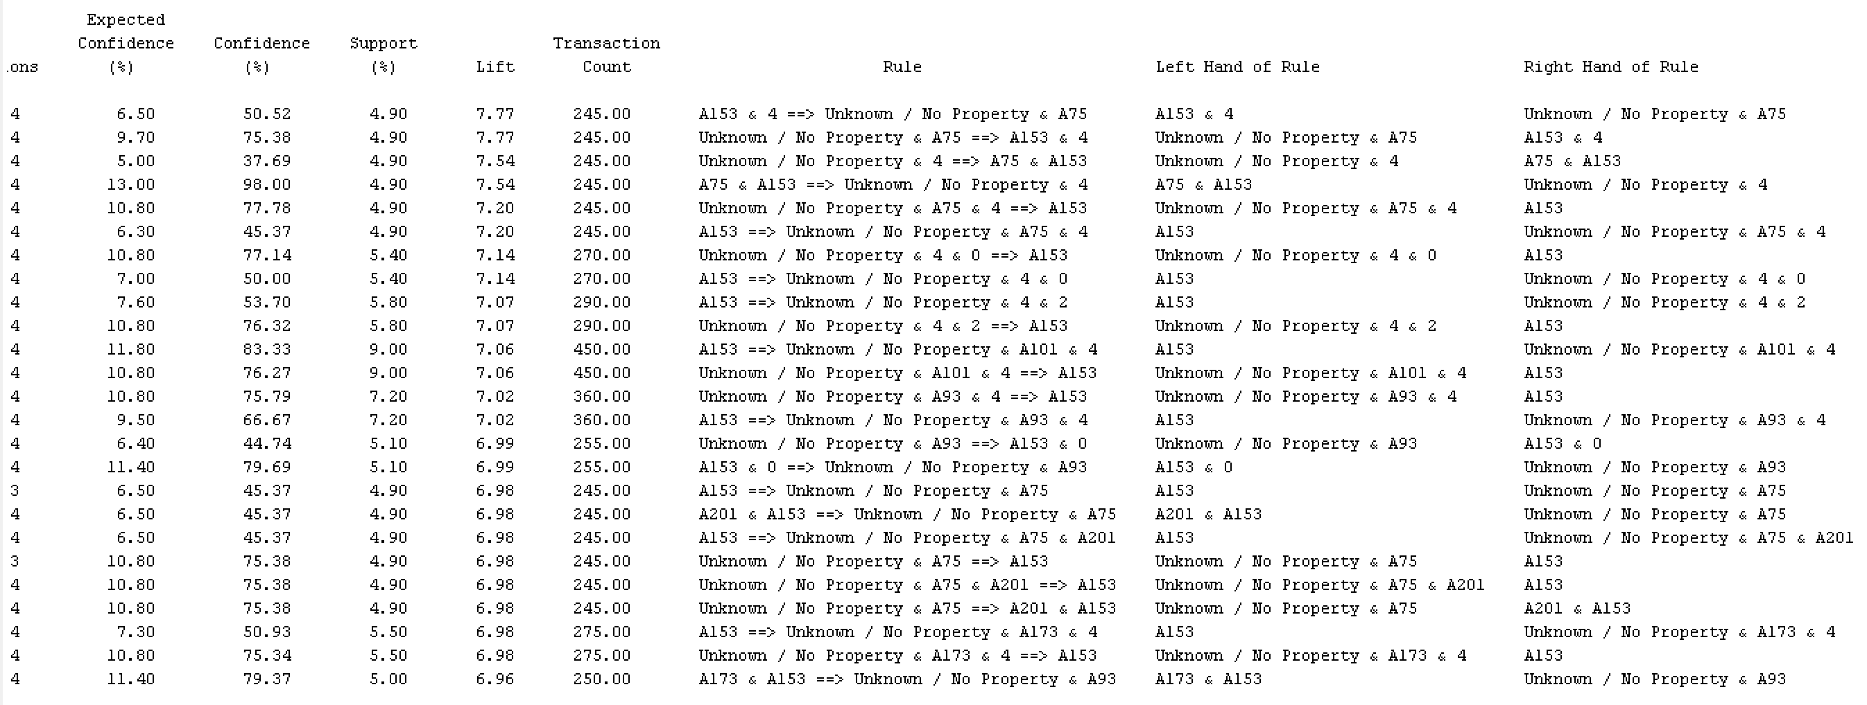

Output Rep Hold Forward Regression / Final Regression:

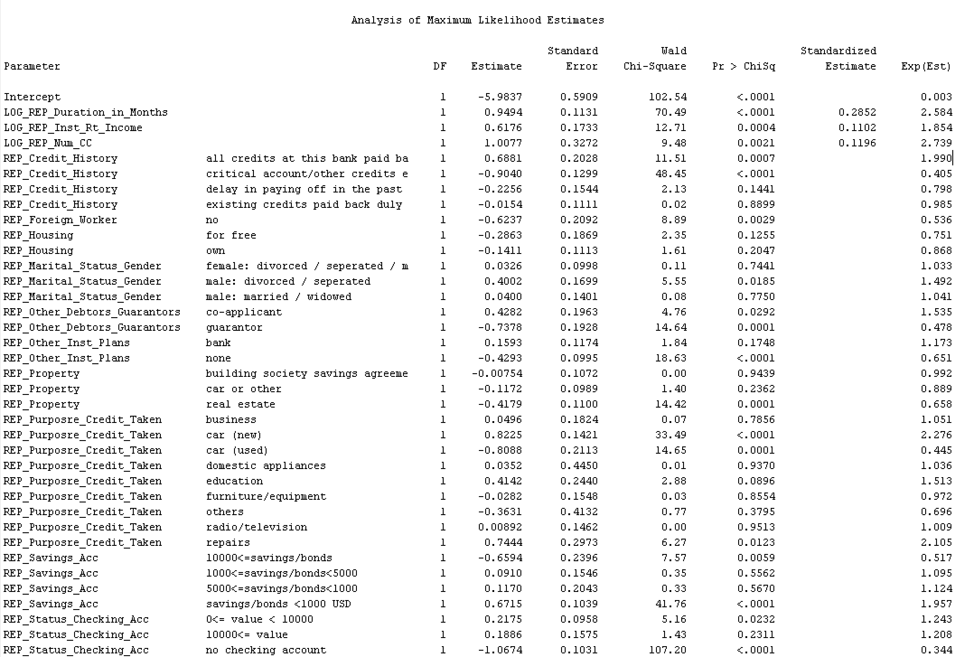

Baseline groups and Odds Ratio Estimates

